ASSIGNMENT 2
UML DIAGRAMS FOR SYSTEM REQUIREMENTS
AND ARCHITECTURE
Evaluate, Design and Validate UML Models for a
Smart Healthcare Appointment System
Course Outcome: CO2
Scenario: Smart Hospital Outpatient Management System (SH-OPMS)
Total Marks: 50 | Duration: 1 Week
Name: MUKESH.M
Register Number: (192521368)
Department: _B.TECH (IT)
Course: Object-Oriented Analysis and Design
ASSIGNMENT 2

Introduction
This assignment develops and evaluates UML models for the Smart Hospital Outpatient Management System (SH-OPMS). The hospital has three campuses and approximately 4,000 outpatient visits per day. The proposed system supports appointment booking, walk-in registration, triage, consultation, laboratory reports, billing, insurance integration, pharmacy communication and administration.
Design assumptions are stated explicitly because the stakeholder brief does not define every business rule. The models use a business-capability architecture and a role-based person model so that the same individual can act as a patient and also hold a staff role.
Important scope note: the following are proposed design decisions for the assignment scenario. They should be confirmed with hospital stakeholders before implementation.

TASK 1 – Requirements Inquiry and Modelling Plan (4 Marks)

1.1 Ambiguity and assumption log
No. | Ambiguity / gap | Question to stakeholder | Temporary assumption
1 | Who can view lab reports? | Can a patient view only their own reports, and can a doctor view reports only for patients under their care? | Patients see their own reports after identity verification; authorised treating doctors see reports for their assigned patients. Access is audited.
2 | What makes a case urgent? | Who assigns urgency and what clinical categories are used? | A trained nurse records triage priority using hospital-approved levels; emergency cases are escalated immediately and bypass the normal queue.
3 | What happens after insurance rejection? | Can the patient pay directly, appeal, or defer the visit? | The invoice remains unpaid; the patient may self-pay or contact the insurer. Pharmacy release follows the hospital's payment policy.
4 | When is an appointment slot reserved? | Is a slot held during payment and for how long? | The service temporarily holds a slot for a short configurable period (for example, five minutes) while payment is processed.
5 | What if payment succeeds but the slot is lost? | How should duplicate or late payment be handled? | The system attempts a safe refund/void, records the failure and offers another available slot.
6 | What is the video consultation process? | Are identity checks, consent and video links required? | Video consultation requires patient verification and consent; a secure meeting link is generated after confirmation.
7 | How long are records retained? | What legal and hospital retention rules apply? | Retention duration is configurable and follows applicable healthcare and privacy requirements; no fixed period is assumed here.
8 | What happens during campus network failure? | Must local registration and triage continue offline? | A limited encrypted local queue supports registration and triage; central clinical history and external integrations may be unavailable until reconnection.

1.2 Classified requirements
ID | Requirement | Type
FR1 | Patient can book, reschedule and cancel appointments using mobile app or reception desk. | Functional
FR2 | Receptionist can register walk-in patients and check them in. | Functional
FR3 | Nurse can record vitals, triage and mark urgent priority. | Functional
FR4 | Doctor can view authorised history, record diagnosis and prescriptions, and order lab tests. | Functional
FR5 | Lab staff can upload reports for authorised patient and doctor access. | Functional
FR6 | Billing can create invoices, accept online payments and submit insurance claims. | Functional
FR7 | Pharmacy can receive prescriptions electronically. | Functional
FR8 | Administrator can manage doctor schedules, users and operational reports. | Functional
NFR1 | Patient information must be private and access-controlled. | Non-functional – security
NFR2 | System must remain available during clinic hours. | Non-functional – availability
NFR3 | Monday-morning peak traffic must not cause unacceptable slowdown. | Non-functional – performance
NFR4 | All important actions and access to records must be auditable. | Non-functional – accountability

1.3 Modelling plan
UML diagram | Concern and reason for selection
Use Case | Functional scope, actors, system boundary and user goals.
Class | Static domain structure, attributes, operations, associations and multiplicities.
Sequence | Time-ordered messages for booking and payment, including failure recovery.
Communication | Object links and numbered messages for a compact interaction view.
State Machine | Appointment lifecycle, guards, events and legal transitions.
Activity | Walk-in workflow, decisions, parallel work, exceptions and hand-offs.
Package | Logical grouping of related classes and subsystems.
Component | Software components, interfaces and dependencies.
Deployment | Physical nodes, execution environments, artifacts and communication paths.

The set is complementary: use cases define what the system must do; class and package diagrams show structure; interaction, state and activity diagrams explain behaviour; component and deployment diagrams connect the logical design to implementation and operations.

TASK 2 – Use Case Diagram: Scope and Boundary Decisions (6 Marks)

2.1 Actors and system boundary
Actor | Type | Reason / responsibility
Patient | Primary | Books, changes or cancels appointments; views own reports; pays bills.
Receptionist | Primary | Registers walk-ins, checks patients in and assists with appointment operations.
Nurse | Primary | Records vitals and performs triage.
Doctor | Primary | Reviews history, consults, diagnoses, prescribes and orders tests.
Lab Staff | Primary | Processes test orders and uploads reports.
Administrator | Primary | Manages schedules, users and operational reports.
Payment Gateway | Supporting external | Authorises online payment; remains outside SH-OPMS because it is an independently operated service.
Insurance Provider | Supporting external | Checks eligibility and processes claims; integrated through an external interface.
Pharmacy | Supporting external | Receives electronic prescriptions; it is a separate operational system or organisation.

The SH-OPMS boundary contains the hospital's appointment, clinical, laboratory, billing, administration and notification functions. The payment gateway, insurer and pharmacy are outside the boundary because they have their own ownership, infrastructure and rules. SH-OPMS communicates with them through defined interfaces.

2.2 Use case diagram
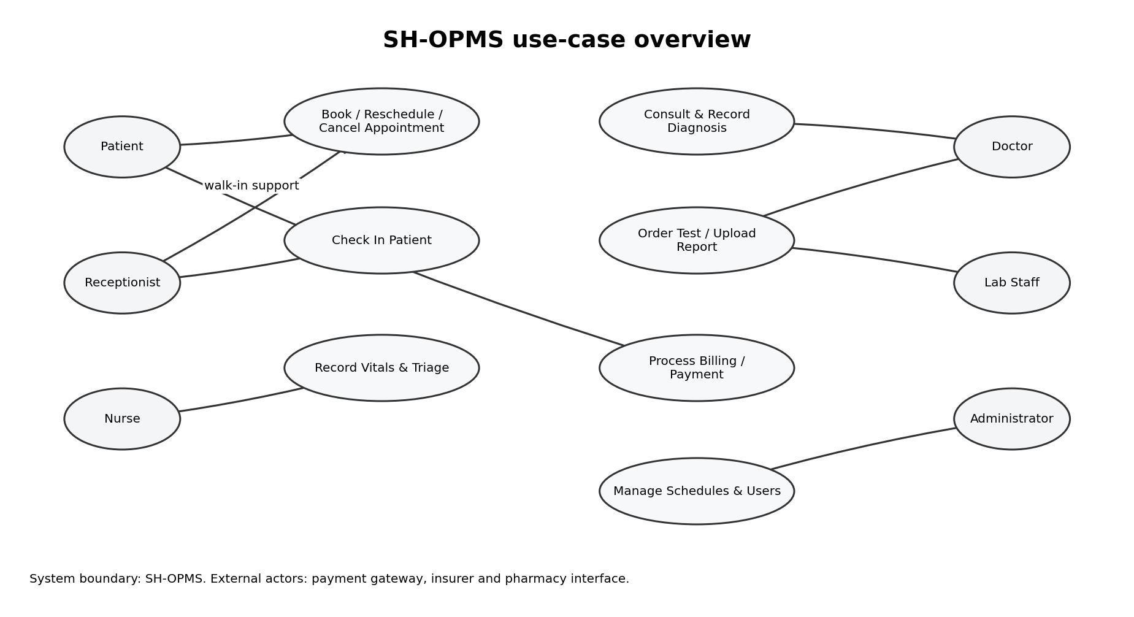
Figure 1. High-level use-case view. External service actors are noted beside the boundary.

2.3 Relationships and alternatives
Proposed relationships: Book Appointment includes Validate Patient and Check Slot Availability. Online Payment is an optional extension when the selected booking requires online payment. Urgent Triage extends the normal triage flow when the nurse identifies an urgent condition. Upload Lab Report follows a valid Lab Order. Generalisation can be used for Staff → Nurse, Doctor, Receptionist and Lab Staff where common staff authentication is shared.
Alternative | Description | Evaluation
A | Make Payment is an <<include>> of Book Appointment. | Simple, but incorrectly implies every appointment booking must use online payment. It can confuse cash, insurance and pay-later cases.
B – selected | Keep Process Payment as a separate use case, optionally linked with booking using <<extend>> or invoked by the billing workflow. | Better represents optional payment channels, supports reuse for consultation invoices and reduces misinterpretation. Slightly more detailed, but clearer.

Final choice: Alternative B. Payment is a separate business capability and can occur through online gateway, reception counter or insurance workflow. The booking use case therefore does not force online payment in every case.

2.4 Critical use case specification – Book Appointment
Field | Specification
Use case | Book Appointment
Primary actor | Patient; receptionist can initiate the same workflow for a walk-in or assisted booking.
Goal | Reserve a valid consultation slot for a patient.
Preconditions | Patient identity is available or can be registered; doctor schedule is published; requested campus/service is active.
Trigger | Patient selects Book Appointment.
Main flow | 1. Patient selects campus, specialty, doctor or available time. 2. System validates patient and retrieves available slots. 3. Patient selects in-person consultation. 4. System places a temporary hold on the slot. 5. Patient chooses payment method. 6. Payment/coverage is processed. 7. System confirms the appointment and stores the booking. 8. Notification service sends confirmation.
Alternate flows | A1: Patient is not registered → create/verify patient profile. A2: Slot unavailable → show alternatives. A3: Payment declined → release hold and show retry or another method. A4: Insurance rejected → offer self-pay or claim follow-up. A5: Slot lost after payment → initiate refund/void, log incident and offer another slot.
Postconditions | Successful: one confirmed appointment exists and confirmation is sent. Unsuccessful: no false confirmed booking remains; temporary hold is released and payment outcome is reconciled.
Why critical | It is the main entry point for outpatient visits and affects waiting time, billing, doctor utilisation and patient experience.

TASK 3 – Class Diagram: Evaluating Structural Alternatives (6 Marks)

3.1 Domain classes and selected structure
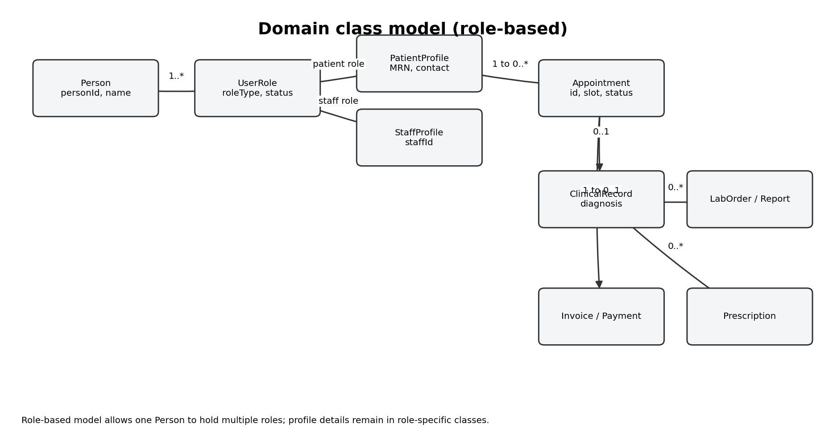
Figure 2. Role-based domain class overview. The full class inventory and operations are listed below.
Class | Key attributes | Example operations
Person | personId, name, dateOfBirth, contact | updateContact(), verifyIdentity()
UserAccount | userId, username, passwordHash, status | authenticate(), deactivate()
UserRole | roleId, roleType, assignedAt | grant(), revoke()
PatientProfile | medicalRecordNo, emergencyContact | viewOwnHistory(), updateProfile()
StaffProfile | staffId, department, campus | viewSchedule(), updateAvailability()
DoctorSchedule | scheduleId, date, startTime, endTime | publish(), blockSlot(), holdSlot(), commitSlot()
Appointment | appointmentId, slotTime, mode, status | requestBooking(), confirmBooking(), reschedule(), cancel(), checkIn(), complete()
ClinicalRecord | recordId, diagnosis, notes, createdAt | addDiagnosis(), viewHistory()
VitalRecord | vitalId, bloodPressure, pulse, temperature | recordVitals(), flagAbnormal()
LabOrder | orderId, testType, status | createOrder(), updateStatus()
LabReport | reportId, reportDate, fileReference | uploadReport(), verifyReport()
Prescription | prescriptionId, medicineList, instructions | createPrescription(), transmitToPharmacy()
Invoice | invoiceId, amount, status | calculateTotal(), issueInvoice()
Payment | paymentId, amount, method, status | authorise(), refund(), reconcile()
InsuranceClaim | claimId, policyReference, claimStatus | submitClaim(), recordDecision()
Notification | notificationId, channel, deliveryStatus | send(), retry()

3.2 Associations and multiplicities
Association | Multiplicity / relationship | Reason
Person – UserAccount | Person 1 — 0..1 UserAccount | A person may be recorded as a patient without app login; an account is optional.
Person – UserRole | Person 1 — 1..* UserRole | One person may hold multiple roles, such as doctor and patient.
Person – PatientProfile | Person 1 — 0..1 PatientProfile | Patient-specific details are separated from general identity.
Person – StaffProfile | Person 1 — 0..1 StaffProfile | Staff details are separate; a person can be both staff and patient.
PatientProfile – Appointment | 1 — 0..* | A patient can have many appointments; each appointment belongs to one patient.
DoctorSchedule – Appointment | 1 — 0..* | A schedule contains multiple booked slots; each appointment uses one slot.
Appointment – ClinicalRecord | 1 — 0..1 | A confirmed appointment may produce a clinical record after consultation.
ClinicalRecord – VitalRecord | 1 — 0..* | A clinical encounter can contain multiple observations.
ClinicalRecord – LabOrder | 1 — 0..* | A consultation may request several tests.
LabOrder – LabReport | 1 — 0..* | An order may produce one or more reports or result parts.
ClinicalRecord – Prescription | 1 — 0..* | A consultation can generate multiple prescriptions.
Appointment – Invoice | 1 — 0..1 | An appointment may create an invoice; some visits may be covered or waived.
Invoice – Payment | 1 — 0..* | Partial, retry or split payments may be recorded.
Invoice – InsuranceClaim | 1 — 0..* | A claim may be submitted, corrected or resubmitted.

3.3 Two alternatives for modelling people
Alternative | Structure | Evaluation
A – Inheritance | Person is a superclass; Patient, Doctor, Nurse, Receptionist and LabStaff inherit from Person. | Easy to understand and shares common fields. However, a doctor who is also a patient may require multiple inheritance or duplicate person records. Adding roles can make the hierarchy rigid.
B – Role-based (selected) | One Person entity is associated with one or more UserRole records and optional PatientProfile / StaffProfile details. | Supports multiple roles without duplicating identity. New roles can be added as data/configuration. Requires careful role validation and can make role-specific rules less obvious.

Decision: choose Alternative B because the scenario explicitly states that one person may hold more than one role. A single identity record avoids duplicated personal data and supports future role additions.

3.4 Aggregation, composition and limitation
- Composition: ClinicalRecord ◆— VitalRecord. A vital observation is part of a specific encounter record in this model and is not independently retained as a detached encounter object. If hospital policy requires longitudinal observations, this may need to become a normal association.
- Composition: Invoice ◆— InvoiceLine (not separately shown in the overview). Invoice lines are created and deleted with the invoice; their lifetime is controlled by the invoice.
- Aggregation/ordinary association: Person — UserAccount is not composition because an account may be deactivated while the person's clinical identity and records must remain.
- Aggregation/ordinary association: LabOrder — LabReport is not composition if reports must remain auditable even when an order is cancelled or corrected.
Remaining weakness: the model does not fully represent consent, guardian relationships, emergency access and fine-grained record permissions. These should be added after privacy and clinical governance requirements are confirmed.

TASK 4 – Sequence Diagram: Behaviour Under Failure (6 Marks)

4.1 Booking with online payment
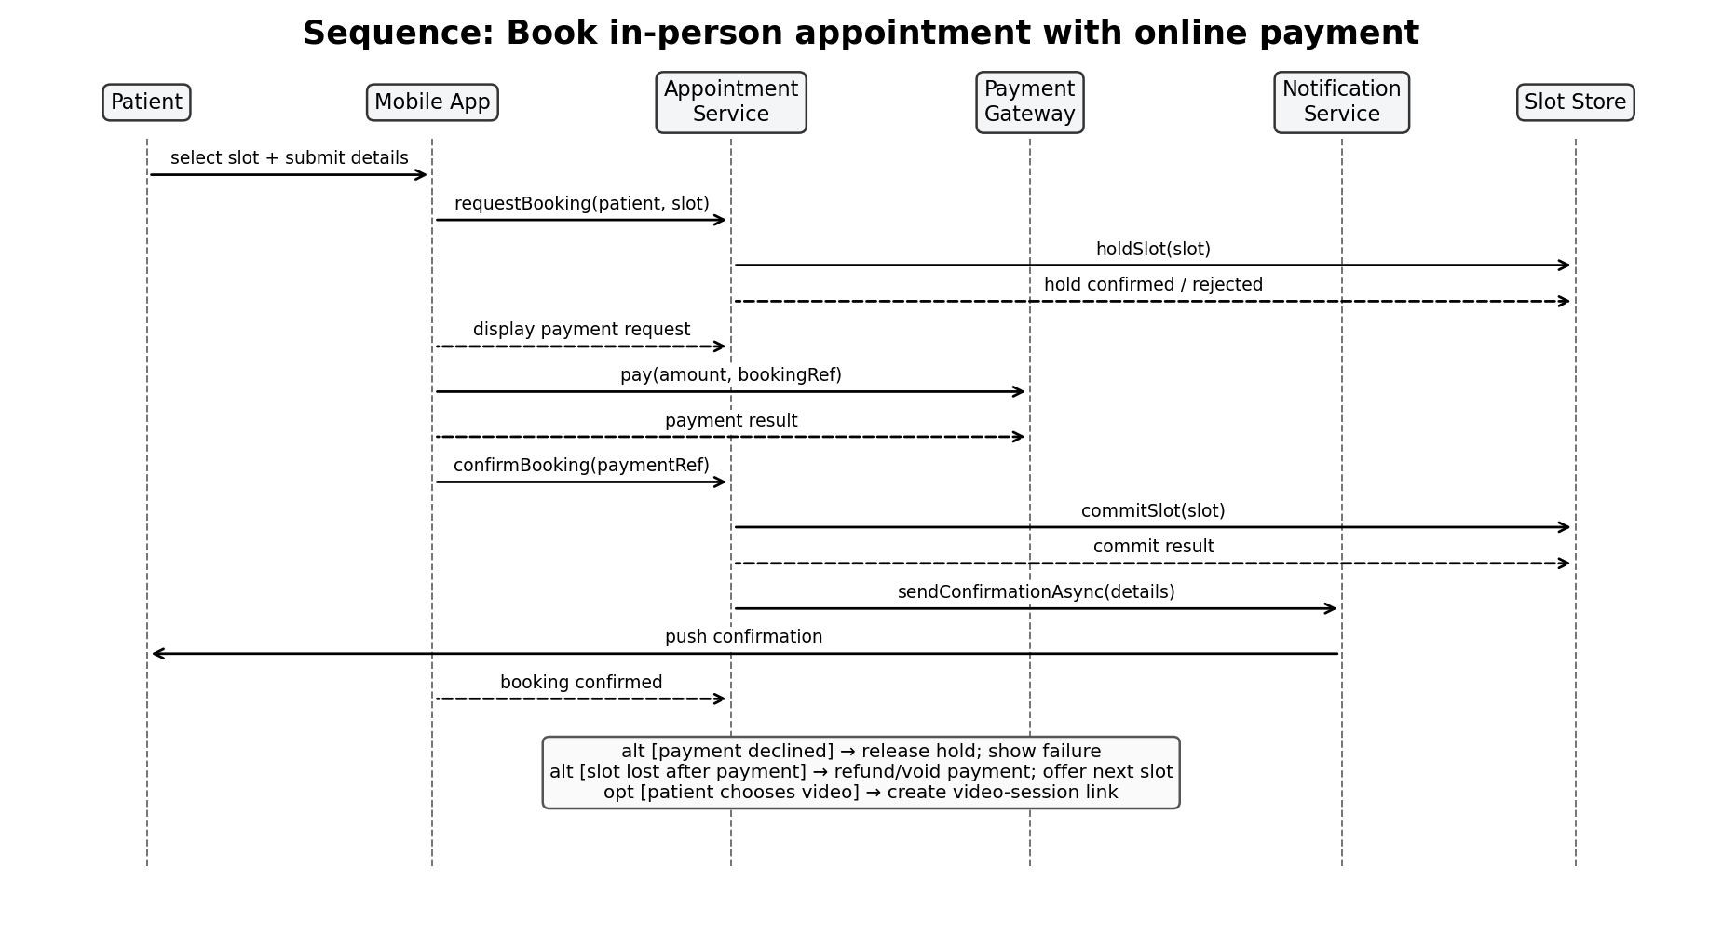
Figure 3. Sequence diagram. Solid arrows represent calls; dashed lifelines show object existence over time. The lower notes summarise alternate fragments.
The interaction uses Patient, Mobile App, Appointment Service, Payment Gateway, Notification Service and Slot Store. Appointment Service first holds the slot, then requests payment. It confirms the appointment only after payment success and a successful final slot commit.

4.2 Synchronous and asynchronous messages
Message | Type | Reason
requestBooking(), holdSlot(), commitSlot() | Synchronous | The booking service needs an immediate result before it can safely proceed or confirm the slot.
authorizePayment() | Synchronous request/response (or bounded callback) | The booking outcome depends on the payment authorisation result. A timeout must be handled as pending, not assumed successful.
sendConfirmationAsync() | Asynchronous | The appointment is already committed; notification delivery can retry without blocking the booking transaction.
push confirmation | Asynchronous | Mobile push delivery may be delayed or unavailable and should not roll back a valid appointment.

If notification were synchronous, a slow messaging provider could delay or prevent appointment confirmation even though the slot and payment are valid. If slot commitment were asynchronous, the system could tell two patients that the same slot is confirmed before the conflict is detected.

4.3 Payment succeeds but slot is taken
- The service initially places a short-lived hold. If the hold expires or a competing transaction commits the slot first, final commit returns a conflict.
- The service marks the booking as failed-to-confirm and does not create a confirmed appointment.
- It requests a void or refund using the payment reference. The operation is idempotent so retries do not create duplicate refunds.
- The patient receives a clear message that payment is being reversed and is offered alternative slots.
- A reconciliation job checks any uncertain gateway response and updates the payment record when the final status is known.

4.4 Message-to-operation consistency check
Sequence message | Class operation / owner | Consistency
requestBooking(patient, slot) | Appointment.requestBooking() | Match
holdSlot(slot) | DoctorSchedule.holdSlot() / Slot service | Added to schedule/slot service contract.
authorizePayment(amount, ref) | Payment.authorise() | Match
confirmBooking(paymentRef) | Appointment.confirmBooking() | Match
commitSlot(slot) | DoctorSchedule.commitSlot() | Added to schedule/slot service contract.
sendConfirmationAsync(details) | Notification.send() | Match
refund(paymentRef) | Payment.refund() | Match

The two slot operations are included in the class inventory. This makes the interaction consistent with the structural model.

TASK 5 – Communication Diagram: Choosing the Right Interaction View (3 Marks)
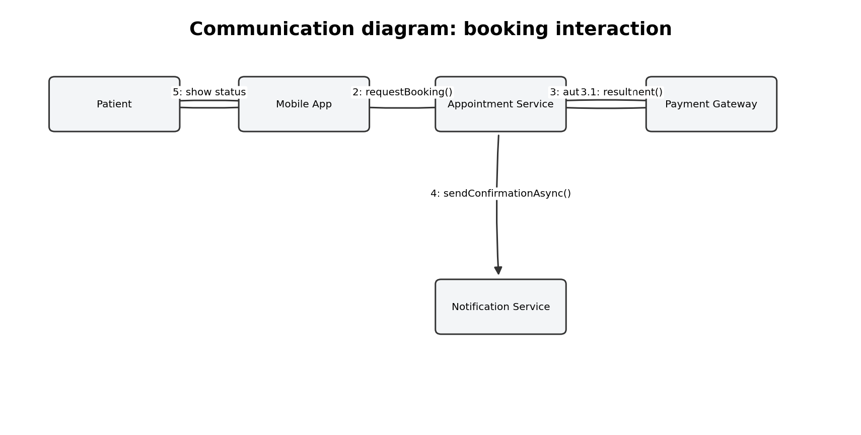
Figure 4. Communication diagram with numbered messages.
The communication view uses the same booking interaction but emphasises which objects are connected and the order of messages. Numbering makes the sequence explicit: 1 choose slot, 2 request booking, 3 authorise payment, 3.1 return payment result, 4 send confirmation asynchronously, and 5 show the outcome.
View | Strength | Best use in this design
Sequence diagram | Shows time order, activation, return messages, alternatives and failure handling clearly. | Best for payment/slot race conditions and explaining what happens before confirmation.
Communication diagram | Shows object relationships and message numbering compactly. | Better when reviewing whether the Patient, App, Appointment Service, Gateway and Notification Service are correctly connected.

TASK 6 – State Transition Diagram: Lifecycle Correctness (5 Marks)
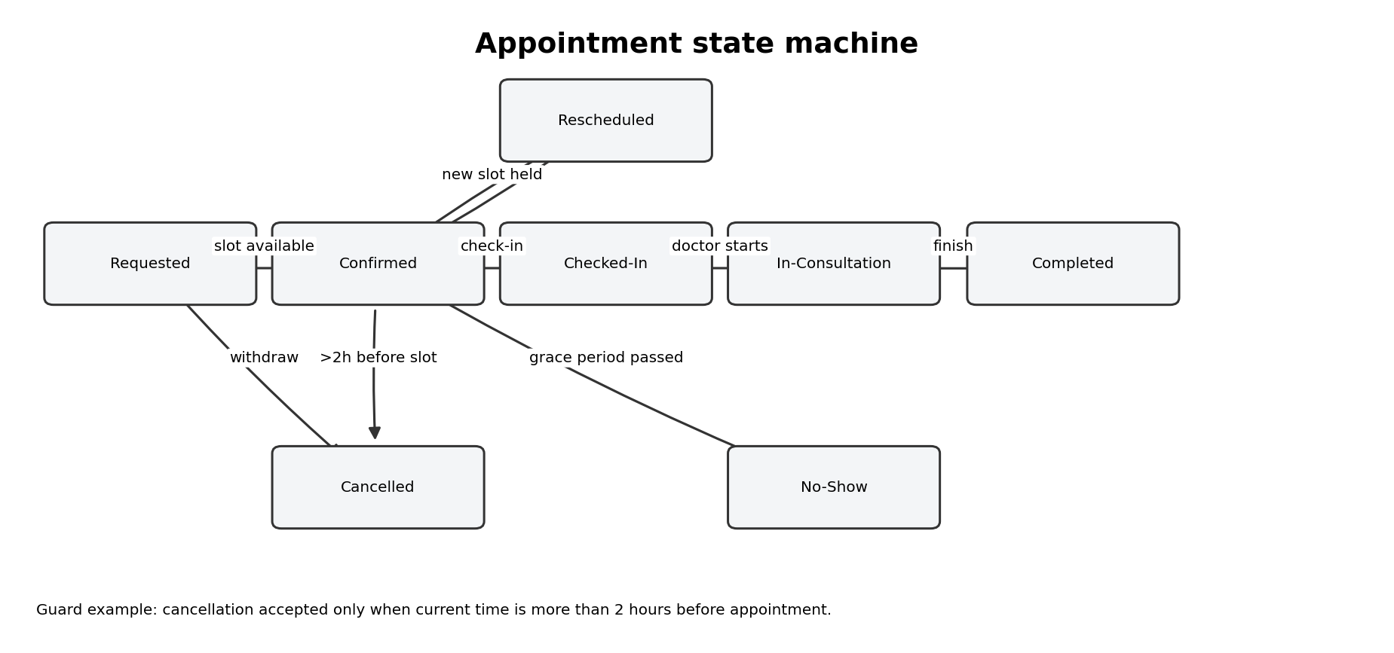
Figure 5. Appointment lifecycle state machine.

6.1 Transition table
Current state | Event | Guard | Next state
Requested | submitBooking | Patient valid and slot available | Confirmed
Requested | withdrawRequest | Always | Cancelled
Confirmed | reschedule | New slot available | Rescheduled
Rescheduled | confirmNewSlot | New slot successfully held | Confirmed
Confirmed | checkIn | Within check-in window | Checked-In
Confirmed | cancel | More than 2 hours before slot | Cancelled
Confirmed | gracePeriodExpired | Patient not checked in | No-Show
Checked-In | startConsultation | Doctor available | In-Consultation
In-Consultation | finishConsultation | Clinical note saved | Completed
Confirmed | cancel | 2 hours or less before slot | Confirmed; cancellation rejected
Checked-In | markNoShow | Not allowed | No-Show transition rejected

6.2 Model verification
- Unreachable states: Rescheduled is reachable from Confirmed; Checked-In, In-Consultation and Completed are reachable in normal clinic flow; Cancelled and No-Show are reachable through separate events.
- States with no exit: Completed and Cancelled are terminal for the appointment lifecycle. They intentionally have no normal outgoing transitions; administrative correction should be an audited exceptional action.
- Undefined events: cancellation after the two-hour cutoff and check-in after the grace period need explicit rejection or exception handling. These are recorded as guarded rejected transitions rather than silent failures.
- Fixes: added a new-slot availability guard for rescheduling, a check-in window, a no-show grace-period event and explicit rejection behaviour for invalid cancellation.

6.3 Guard and No-Show decision
The cancellation guard is “more than two hours before the appointment.” If the guard is missing or incorrect, patients may cancel too late, leaving unused clinical capacity, or may be blocked from a cancellation that policy permits. The threshold must be configurable and approved by hospital management.
No-Show is modelled as a state, not only an event, because it is a persistent outcome used for reporting, follow-up, possible fees and appointment history. The event that moves the appointment into the state is gracePeriodExpired.

TASK 7 – Activity Diagram: Critique and Improve a Workflow (5 Marks)

7.1 Defects in the junior workflow
- Urgent cases are not identified or moved ahead of the normal queue.
- The flow assumes every patient goes directly from triage to doctor, with no queue or doctor availability check.
- There is no branch for lab tests ordered during consultation and no wait for reports or doctor review.
- Insurance eligibility and claim approval are missing; payment is treated as one simple step.
- Pharmacy dispensing is shown regardless of prescription validity or payment/insurance policy.
- There is no exception handling for missing patient details, unavailable doctor, failed payment or lab delay.
- Swimlanes and object hand-offs are missing, so responsibilities are unclear.

7.2 Corrected activity workflow
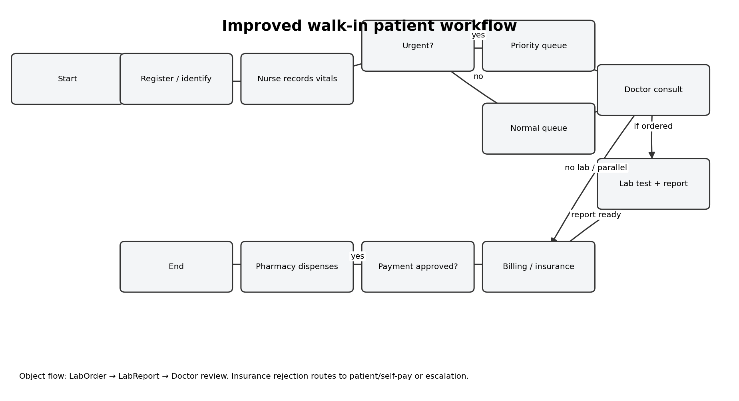
Figure 6. Improved walk-in workflow. Decisions split urgent/normal queue and payment-approved/rejected paths.
Swimlane responsibilities: Receptionist registers or identifies the patient; Nurse records vitals and assigns triage priority; Doctor consults and may create a LabOrder; Lab Staff performs the test and uploads a LabReport; Billing handles payment or insurance; Pharmacy releases the prescription according to hospital policy.
Object flow: the doctor creates a LabOrder object; laboratory staff updates it and produces a LabReport object; the report is routed back to the clinical record for doctor review. Prescription is a separate object sent electronically to the pharmacy.
Parallel work: after registration, the system can verify patient identity/coverage while the nurse records vitals, provided this does not delay urgent clinical assessment. After consultation, billing preparation and report processing may proceed in parallel where policy allows.

7.3 Waiting-time bottleneck and improvement
The most likely measurable waiting time is the queue between triage and doctor consultation, especially during Monday-morning peaks. Record arrival time, triage completion time and consultation start time to calculate the waiting interval by priority level.
Improvement: use nurse-assigned priority queues and live doctor-capacity information. Urgent cases are routed to the priority queue; routine patients are assigned to the next suitable available doctor. This reduces avoidable waiting without allowing routine work to hide urgent cases.

TASK 8 – Package and Component Diagrams: Evaluating the Architecture (5 Marks)

8.1 Package diagram
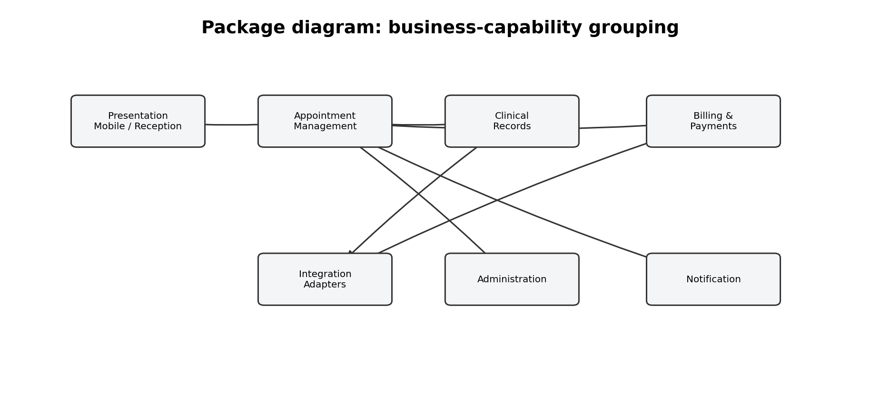
Figure 7. Logical packages organised by business capability.

8.2 Alternative architectural groupings
Grouping | Advantages | Disadvantages
By user role (Patient, Doctor, Nurse, Reception, Lab, Admin) | Easy to assign screens and teams by user group; responsibilities appear familiar to stakeholders. | Duplicates business rules across roles; cross-role workflows become tightly coupled; a change to appointments may require edits in several role packages.
By business capability (selected: Appointments, Clinical, Billing, Pharmacy, Administration, Integration) | Higher cohesion around business rules; easier to reuse services across mobile and reception channels; changes are localised by capability. | Requires clear API ownership and coordination for end-to-end workflows.

Selected approach: business-capability grouping. It keeps appointment rules in one place regardless of whether a patient uses the mobile app or receptionist desk.

8.3 Component diagram and interfaces
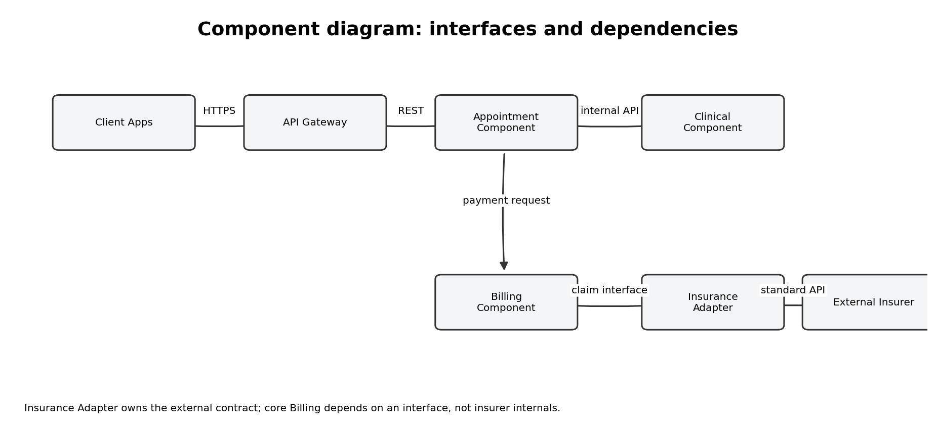
Figure 8. Component-level dependencies and external insurance adapter.
Main components: Client Apps, API Gateway, Appointment Component, Clinical Component, Billing Component, Notification Component, Integration Adapter and persistence services. Provided interfaces include appointment operations, clinical record operations and invoice operations. Required interfaces include payment authorisation, insurer claim processing, pharmacy prescription delivery and notification delivery.
The risky dependency is direct coupling between Billing and a particular insurer's internal API. It is contained by an Insurance Adapter that exposes a stable ClaimSubmission interface. The adapter translates SH-OPMS claim data to the insurer's external format and isolates credentials, retries and provider-specific errors. Billing depends on the interface, not the insurer implementation.
Avoid circular dependencies: Clinical may publish a prescription event; Pharmacy Integration consumes it. Pharmacy Integration should not call back into Clinical internals. Use documented APIs or events.

TASK 9 – Deployment Diagram: Fitness for Operational Needs (4 Marks)
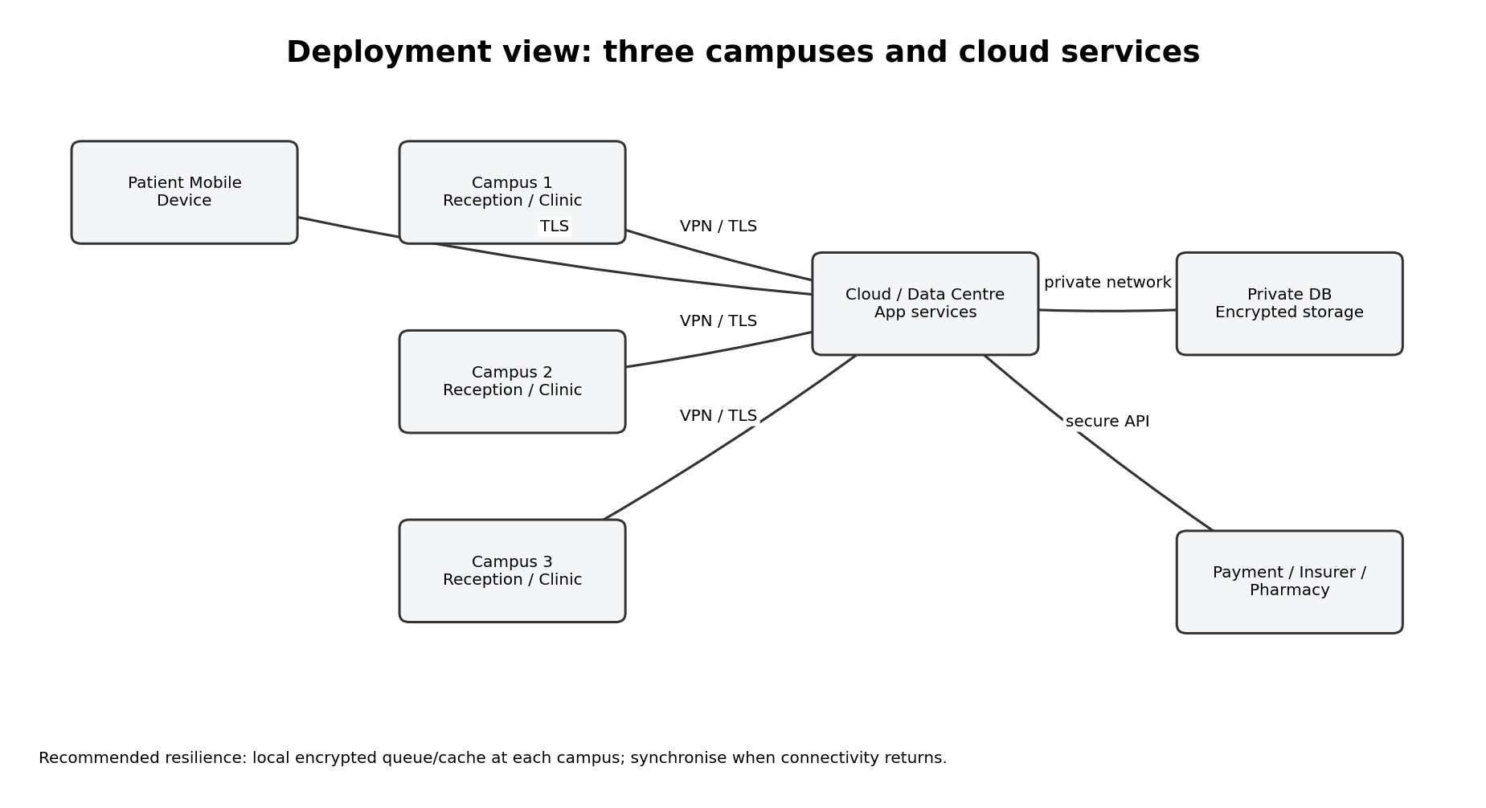
Figure 9. Proposed deployment across three campuses, cloud services and external systems.

9.1 Component-to-node mapping
Node | Deployed components / artifacts | Reason
Patient mobile device | Mobile app; secure local session token | Patient access from outside the hospital using TLS.
Campus 1, 2 and 3 | Reception and nurse workstations; browser client; optional encrypted offline queue | Local staff access at each campus; limited operation during a WAN outage.
Cloud / data centre | API Gateway, Appointment, Clinical, Billing, Notification and Integration services | Centralised business rules and shared records across campuses.
Private database node | Patient, appointment, clinical, invoice and audit data stores | Central backup, access control, encryption and managed database operations.
External provider nodes | Payment gateway, insurance provider and pharmacy systems | Remain independently operated and are reached through secure interfaces.

9.2 Non-functional evaluation
Need | Deployment measure | Evaluation
Privacy | TLS for network traffic, encryption at rest, role-based access, least privilege, audit logs and restricted admin access. | Protects data in transit and storage; access controls reduce unauthorised viewing. Security testing and policy review remain necessary.
Availability during clinic hours | Redundant application instances, health checks, database backups/replication and monitored failover. | Reduces single points of failure. External gateway or campus connectivity may still be an outage dependency.
Monday peak load | Load balancer, horizontal scaling, caching of non-sensitive reference data, queue-based notifications and database performance monitoring. | Scales stateless services and prevents notification traffic from blocking booking transactions. Capacity tests must use realistic peak traffic.

9.3 Changed condition: one campus loses internet for two hours
Still works: local patient registration, queue token creation, basic vitals capture and encrypted offline recording can continue if the campus has a local continuity service. Staff can view only the minimum cached information that policy permits.
Does not fully work: central appointment availability, cross-campus updates, online payment, insurer eligibility checks, pharmacy transmission and access to uncached central clinical history. Staff must clearly see that records are pending synchronisation.
Improvement: deploy a small campus edge service with encrypted local queue, durable event log and conflict-aware synchronisation. Trade-off: additional cost, patching and monitoring; local copies increase data-protection responsibility, and delayed synchronisation can create temporary data conflicts.

TASK 10 – Cross-Model Review, Change Impact and Final Defence (6 Marks)

10.1 Traceability matrix
Requirement | Use case | Classes | Behaviour model | Component | Node
FR1 Book/reschedule/cancel | Book Appointment | Person, PatientProfile, Appointment, DoctorSchedule | Use case; sequence; appointment state | Appointment Component | Mobile / reception client; cloud services
FR2 Walk-in registration/check-in | Register Walk-in; Check In | Person, PatientProfile, Appointment | Use case; activity; state | Client + Appointment Components | Campus workstation; cloud
FR3 Vitals and triage | Record Vitals & Triage | VitalRecord, ClinicalRecord, UserRole | Use case; activity | Clinical Component | Nurse workstation; cloud
FR4 Diagnosis, prescription, lab order | Consult Patient | ClinicalRecord, Prescription, LabOrder | Use case; sequence/activity | Clinical Component | Doctor workstation; cloud
FR5 Upload and view lab report | Upload Lab Report | LabOrder, LabReport, PatientProfile | Use case; activity | Clinical / Lab Integration | Lab workstation; cloud storage
FR6 Billing, payment, insurance | Process Billing / Claim | Invoice, Payment, InsuranceClaim | Use case; sequence | Billing + Insurance Adapter | Cloud; payment/insurer endpoints
NFR1 Privacy | Authenticate / Authorise Access | UserAccount, UserRole, AuditRecord | Use case/security constraints | API Gateway + Identity service | All nodes; encrypted database
NFR2 Availability | Core outpatient workflows | Appointment, ClinicalRecord | Deployment and operational workflow | All core services | Cloud + campus continuity nodes

10.2 Inconsistency log and corrections
Inconsistency found | Correction
Sequence diagram used holdSlot() and commitSlot(), but the initial class list did not show these operations. | Added holdSlot() and commitSlot() to DoctorSchedule / slot service contract.
The simple junior workflow moved every patient directly to the doctor, conflicting with urgent triage requirements. | Added triage decision and separate priority/normal queues in the activity and state views.
A use-case alternative made online payment mandatory for every booking, conflicting with counter payment and insurance. | Separated Process Payment from Book Appointment and made payment-channel selection explicit.
The component view could have coupled Billing directly to an insurer API, conflicting with independent external ownership. | Introduced Insurance Adapter and a stable claim interface.

10.3 Change impact: tele-consultation and shared e-prescriptions
Diagram type | Must change? | Change required
Use Case | Yes | Add Start Tele-consultation, Join Video Session and Share E-prescription; add external receiving hospital/pharmacy actors if applicable.
Class | Yes | Add ConsultationSession, VideoSessionLink, Consent and PrescriptionShare/Recipient organisation details.
Sequence | Yes | Add video-session creation, patient/doctor join, identity/consent checks and secure e-prescription transfer.
Communication | Yes | Add Video Service and external prescription recipient objects with numbered messages.
State Machine | Likely | Add consultation mode/session states or a linked ConsultationSession lifecycle; appointment state remains reusable.
Activity | Yes | Add remote identity verification, consent, video consultation and prescription-sharing paths.
Package | Yes | Add Tele-consultation capability and external prescription-sharing integration package.
Component | Yes | Add Video Consultation and E-prescription Exchange components/interfaces.
Deployment | Yes | Add secure media service, video infrastructure and external connectivity endpoints.

The hardest diagram to keep correct is the sequence diagram because it must remain consistent with timing, asynchronous callbacks, retries, payment outcomes, video-session events and external prescription delivery. A small change in one service can alter several message paths and failure branches.

10.4 Reflection and final defence (about 200 words)
The design decision I am least confident about is the proposed offline operation at each campus. The scenario requires the system to remain available during clinic hours, but it does not specify which clinical records may be cached, how long an offline transaction may remain pending, or how conflicting updates should be resolved. I would change this decision after reviewing hospital privacy policy, interviewing doctors and receptionists, and testing a real network outage with representative data. Evidence should include recovery time, data-loss tests, conflict rates and staff feedback. I would also validate the two-hour cancellation rule with hospital management because it affects patient fairness and doctor utilisation. For stakeholders, the use-case diagram delivers high value because it makes responsibilities and system boundaries understandable without technical detail. The activity diagram is also valuable because it exposes urgent-care routing, laboratory hand-offs and billing delays. For developers, the class diagram gives the most useful domain structure, while the sequence diagram explains the exact booking/payment interactions and failure recovery. Together, these diagrams connect user needs to implementation decisions. The models should be reviewed with clinical, billing, IT and privacy representatives before development begins.

Conclusion
The proposed SH-OPMS design covers the ten assignment tasks and links requirements to UML structure, behaviour, architecture and deployment. The selected role-based person model supports people with multiple roles; business-capability packages improve cohesion; the payment and insurance integrations are isolated behind interfaces; and the workflow gives urgent patients priority. The design also identifies assumptions and remaining risks instead of treating incomplete stakeholder information as settled fact.

References / Modelling basis
Primary source: Assignment 2 – “Evaluate, Design and Validate UML Models for a Smart Healthcare Appointment System” (user-provided assignment brief). All requirements and scenario details in this document are based on that brief. Proposed assumptions and design choices are labelled in the relevant sections.
Diagram notation is based on standard UML concepts: actors and use cases; classes and relationships; sequence and communication interactions; state machines; activities and swimlanes; packages, components and deployment nodes.

